Kindergarten Supply List
Scenic Park Elementary
Need List:
- Bulk snacks (individually packed preferred) 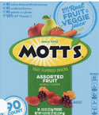
- 3+ Elmer’s Glue sticks 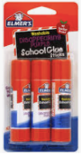
- 3+ Expo dry erase markers (standard size, not thin markers)
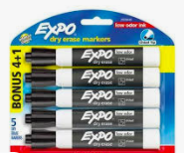
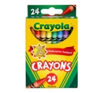
- 24 Pack Crayons (Crayola preferred)

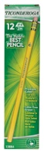
- Pencils (Ticonderoga preferred)
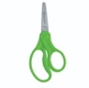
- 1 Pair child safety scissors
- 1 Large standard box of Kleenex 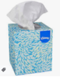
- 1 Container Clorox (or Costco brand) disinfecting wipes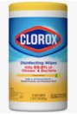
- 1 Box of Ziploc bags: Gallon, quart, or sandwich size

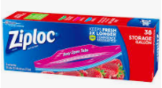
- 1 Pair Headphones/earbuds (Not wireless)

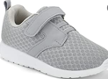
- PE Shoes to leave at school *If your child does not know how to tie shoelaces, please provide shoes without laces

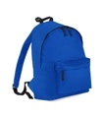
- Backpack *large enough to hold snow gear

Wish List (not necessary but helpful):
- 1 ream (package) white cardstock

